

Literacy Policy

Policy Reviewed: | September 2020
Policy approved by Governing Body: | 5th October 2020
Review Cycle: | 3-yearly
Date of Next Review: | September 2023

Policy addendum:

The following changes below were made to this Policy:

a. Information about KS2 Literacy (Reading sessions and writing sessions) was updated and now match the St. Monica’s Literacy document.
b. Information about EYFS and KS1 Phonics scheme (Read write Inc.) was updated.
c. Information about assessment and marking was updated.

Signed: CRodrigues

Designation: Literacy Coordinator Date 16.9.20
St Monica’s Catholic Primary School

Literacy Policy

Our aims in teaching literacy are that all children by the end of Year 6 will:
- be able to communicate effectively and confidently in Standard English.
- be able to listen attentively with understanding, pleasure, and empathy.
- be able to read a wide range of texts for enjoyment and information fluently, critically and with understanding.
- be able to write effectively for a range of audiences and purposes.
- be able to have a conscious control and choice in their use of grammar and punctuation.

Speaking and Listening:
Throughout the school day, children are provided with daily opportunities to develop their confidence as confident and fluent speakers. Speaking and listening skills are encouraged and developed in all year groups and in a range of subjects. At St. Monica’s, year groups have been carefully allocated core texts that act as a stimulus for further promoting speaking and listening skills in class. Furthermore, this is accomplished through staff employing a range of teaching and learning including:
- The use of talk partners
- Think, Pair, Share
- Class discussion and debates
- News sharing
- Retelling stories and reciting poetry
- Talk for Writing
- Role play and drama
- Class reader time
- Listening to a range of texts read aloud by adults, peers and authors and storytellers
- Peace and Justice (Gospel assembly)
- Assemblies

Reading:
At St Monica’s we believe the most important skill for any child leaving primary school is the ability to read independently and effectively for meaning. Through our interpretation of the 2014 Primary National Curriculum, reading encompasses all areas of learning. Each year group has been carefully allocated core texts (fiction, non-fiction, and poetry) that are used in both reading sessions and as the stimulus to teach pupils to speak and write in the literacy lessons. Having engaging texts ensures that the pupils at St. Monica’s read for pleasure.

- Reading is taught and supported through:
  - Class reader time. This is when the class teacher or support staff read the allocated class reader book to the children. Whole class reading develops listening skills, a love of story and reading for pleasure. As this is teacher led all children can enjoy a text that is slightly above what they can read. As a result, the children are exposed to a wider range of vocabulary and the teacher models good reading using expression and fluency. In KS1, Children choose a picture book at the end of the day to be read.

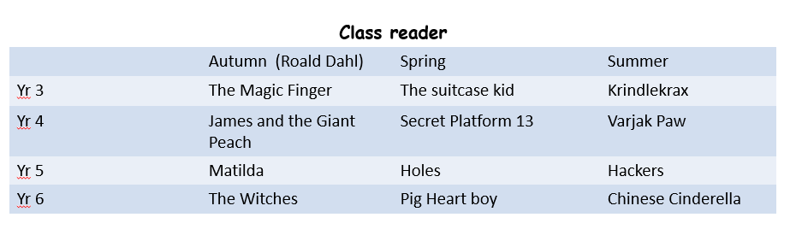

  - In KS1 reading takes place every morning. In Year 1, Read Write Inc. takes place daily with children in ability groups. These groups are fluent, and children are assessed regularly to ensure they are making progress. RWI focuses on a systematic synthetic approach to teaching sounds and reading which ensures all children make progress and are set up to succeed. Children take RWI ‘book bag books’ home that match the sounds they are working on in their groups. Year 2 children are also assessed using the RWI programme, with some Year 2 children in RWI groups with Year 1. Year 2 children who no longer use RWI are read with daily using the ‘Daily supported reading programme’. Levelled sets of guided reading books are stored together in the Meeting Room. In the summer term of Year 2 children are introduced to the reading approach used in KS2.

  - Reading in KS2 involves children reading in pairs and using reading strategies to support their understanding of texts. Each child reads with an adult at least once a week and individual reading trackers are kept that assess children on fluency and understanding of the text. KS2 have been carefully allocated core texts for the year. These change fortnightly and cover fiction, non-fiction, and poetry.

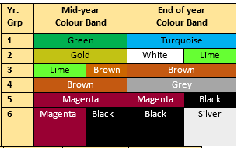
  - Independent reading in school and at home. Children select books from their allocated colour band and take it home to read. This book will be recorded in a reading record book. Children/ teachers fill in the record book during registration time each morning. Reading records are to be signed by parents/ carers daily. Reading records that are not signed should be noted with a BNS (book not signed).

  - Maintaining a print-rich environment which encourages children to interact with displays. Within the classroom, the reading area is attractive and inviting, books are clearly accessible within labelled categories, by author or by genre. Themed displays are encouraged along with opportunities to write book reviews and to display hand-made books. Books are also displayed and promoted around the classroom which may link to topics being learnt in class. In EYFS and KS1 book corners enhance the reading environment and process by using story props and puppets.

  - The school library provides children with a large collection of books. The library is an inviting, child friendly area for all pupils from EYFS to Year 6. A timetable is used to promote regular use of the library for all classes.

Reception and KS1 Literacy
Literacy in Reception and KS1 is using the Read Write Inc. programme. The RWI programme covers reading, writing and SPaG. In Year 2, Children are assessed using the RWI proforma. Some children in Year 2 continue with RWI until they complete the scheme. RWI in Reception is for 15 minutes at the start of the year and towards the end of the year can be up to one hour, depending on the child’s group. In Year 1 and Year 2, it lasts the full hour daily. Children are taught the learning behaviours and the pure sounds in a systematic way from Reception which means that children receive a consistent approach to the teaching of phonics.

KS2 Reading:
At St. Monica’s we have adapted Destination Reader for our approach to teach reading and comprehension in KS2. Reading takes place daily in KS2 for 30 minutes. On Friday’s KS2 complete an unseen comprehension using SAP and CLEAR to support the written answers to comprehension questions.

Learning Behaviours
Reading in KS2 blends a range of learning behaviours and reading strategies which allow children to explore and understand texts independently, at a deeper level. Talk and cooperative learning are central to our approach to reading and as such sessions we encourage children to:

- Support and actively listen
- Discuss and explain their ideas
- Take responsibility for their own/their group’s learning

KS2 Reading Strategies

By concentrating on individual or a combination of reading strategies, teachers can support and challenge children’s use of these skills, thereby raising the quality of their understanding of the text. The children’s oral responses are supported using language stems relating to each strategy. The stems, reading strategies and key vocabulary relating to the text and ‘WOW’ answers are displayed on the Reading Wall and the children have access to them in the form of bookmarks on tables during independent/partner reading.
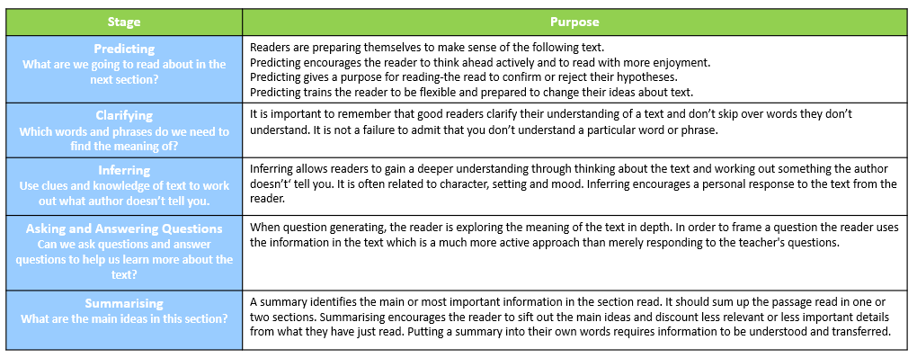

Progression of reading strategies

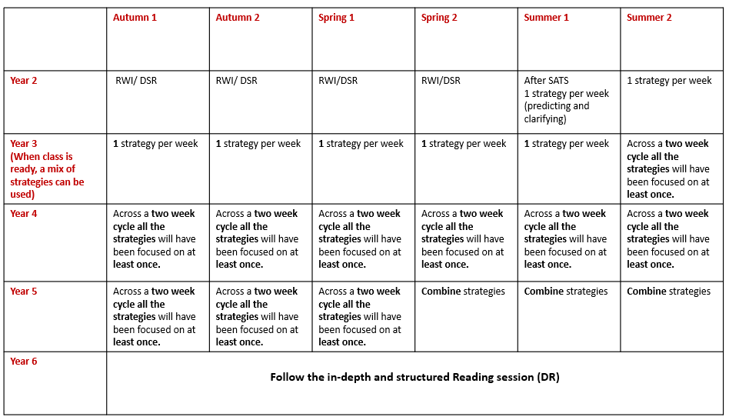
There is progression in the reading strategies and how many should be taught in a week. For most of Year 3, only one strategy is taught throughout the week to ensure that children are confident in using the strategy. However, as children move through KS2 they progress from using the strategies individually to combining them. From Year 4, children are covering all the strategies within a two-week period with teachers planning carefully to ensure that the strategy being taught works well with the text.
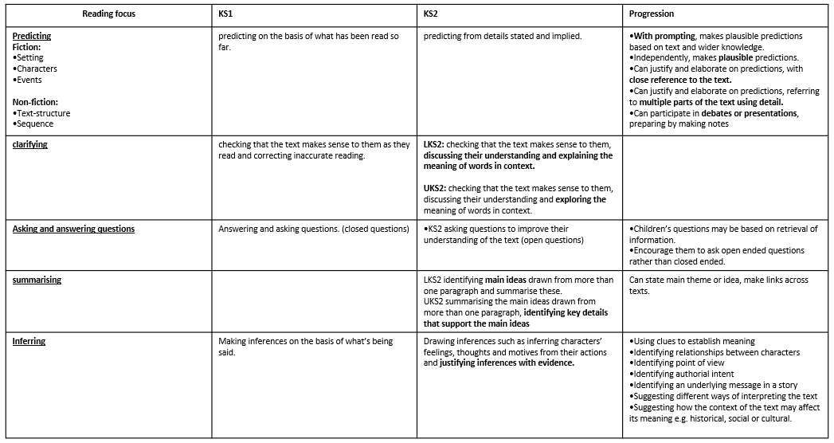

There is also progression within the reading strategy and the skills children use to support the strategies being taught. For example, if the reading strategy is ‘Asking and Answering Questions’, KS1 children will be asking and answering closed questions and KS2 children are encouraged to ask and answer open ended questions.

Weekly reading timetable
At St. Monica’s we promote partner reading to promote confidence, develop their use of the reading strategies, gain exposure to challenging texts and develop cooperative learning behaviours. Mixed ability partners are used in the reading sessions and changed regularly. The children also have the opportunity each week to read at their instructional level to build fluency. Each Friday they answer questions in a written format using SAP and CLAR to support them. All reading discussions and answers are oral so that the focus remains on the children reading and using the strategies (apart from Friday’s session). Teacher reading comments are recorded in the Individual reading tracker.

The structure of the week in Years 3-6 with recording expectations, is as follows:
Monday | Tuesday | Wednesday | Thursday | Friday
Strategy lesson  Partner reading | Strategy lesson  Partner reading | Strategy lesson  Partner reading | Independent reading | Unseen comprehension
Oral discussion/ plenary | Oral discussion/ plenary | Oral discussion/ plenary | Individual reading tracker completed by CT/ TA | Recorded answers in Literacy book.

*Before Year 6 SATs, Year 6 spend more time completing unseen comprehensions.

Reading Assessment Years 3-6
Assessment of reading is two-fold and involves both book level and children’s use of the strategies to understand the texts they read.
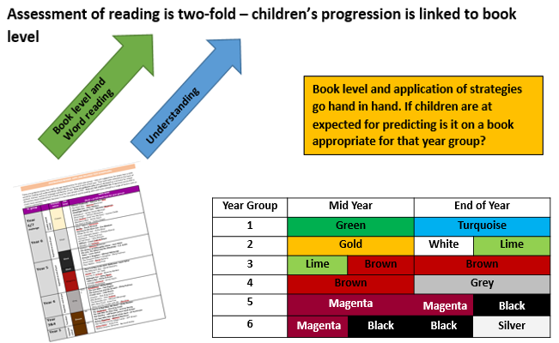

At St. Monica’s we therefore assess and track book level, as well as comprehension. The ways in which we assess children’s reading, the recorded evidence of this and the expectations of frequency are outlined below:

Assessing Book Level
Form of assessment | Evidence | Frequency
1:1 reading | Individual tracker – book band checked and observational comments | Each child is heard read each week, with home reading books changed
Partner Reading/ discussions | ‘WOW’ answers | daily
Each half term teachers use the above information to update their Whole class book band tracker.

Assessing Comprehension
Form of assessment | Evidence | Frequency
Unseen comprehension | Children’s answers recorded in their Literacy books | x1 comprehension recorded per week
Summative assessments | Test papers | Half termly
Teachers use the evidence regarding book level and comprehension, as well as their in-class assessments and knowledge of the children, to decide each term if children are on track for end of year expectations.

Planning
Each year group (Years 2 -6) have been allocated class books for the year. These books are carefully chosen for each year group and progress in level as the year goes on. The allocated books are used for the reading sessions and the writing sessions as a stimulus for the writing activities. Teachers have planned a yearly overview which shows grammar and punctuation objectives and a writing outcome. Teachers have been given a two-week cycle to follow which shows the progression of the lessons. Over a two-week cycle, literacy lessons are linked to the core text from the reading session. These lessons are repeated fortnightly based on different texts.

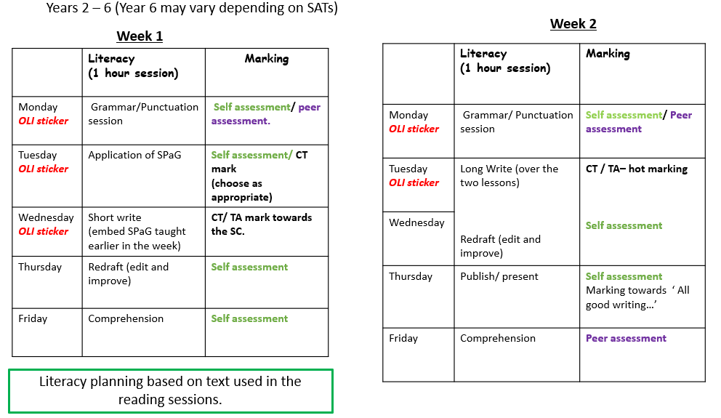

In addition to the two-week cycle, all OLI stickers and Success Criteria have already been created for teachers to use. Staff members refer to the ‘St. Monica’s Literacy’ document where the National Curriculum aims for grammar, spelling and punctuation have been broken down into year groups. In this document, there is also teaching ideas, a table showing the progression of genres and lesson plan ideas to teach writing. By having all these resources ready, it allows teachers to spend less time making these and ensuring that their time is focused on making lessons interesting, purposeful, and engaging for all pupils. Teachers are encouraged to plan backwards; thinking about what they want the writing outcome to be and working their way back thinking about which skills, grammar and punctuation children will need to be able to complete the writing outcome to a high standard.

Writing:
We believe that writing should be a creative and developmental process both at a functional and an imaginative level. All attempts at writing are valued and we know that all children have potential to be successful writers. The compositional and transcriptional skills are taught alongside the creative aspects. Immersion in reading, speaking and preparation for writing are essential to the writing development process.

- Writing is taught through:
- Shared writing that is modelled by the teacher as the expert writer with contributions from the children.
  - Shared writing is not exclusive to literacy sessions and can be taught within Foundation subjects. The emphasis may be on the generation of ideas, grammatical awareness, spelling and phonics, compositional, transcriptional, presentational, and text-level skills or other key strategies needed in writing. Not all of these can be modelled in one session, but the teacher as the expert writer leads the cumulative writing process.
- Guided writing that targets children at their point of writing.
  - Guided writing takes place in small groups with a teaching focus derived from class, group and individual targets and writing already modelled. Guided groups are annotated onto the Literacy flipcharts, so that teachers have a running record of which children have had this support. The main part of the session is spent by the child writing with the adult intervening as appropriate. In Foundation stage the child receives more individualised support from the teacher at the point of writing.
- Opportunities for developmental writing.
  - In EYFS, children should experience writing in a range of settings and opportunities for developmental writing should be available through all areas of learning and throughout the learning environment. Children’s own attempts at early writing should be celebrated and promoted, alongside the direct teaching of the key skills that will enable the children to progress through the stages of writing development. In EYFS and KS1, children’s writing that needs interpretation must be scribed by a teacher or adult working with the group. Ideally this is during the literacy session.
- Independent writing.
  - Throughout the school, children need opportunities to develop their confidence and practise their writing skills. All writing activities should have a purpose and quality should be promoted through publication or presentation to another audience. Writing is modelled and supported from emergent mark-making to fluency. Independent writing is supported using dictionaries, word banks, writing frames or plans and RWI sound cards. Opportunities for independent writing are also provided through Big Write, these are done in topic sessions which allow children to write for a different purpose. Children are encouraged to write as much as they can, in an accurate, interesting, and imaginative way. In Year 1, they have weekly Big write sessions where children are encouraged to use the sounds they have been learning accurately in their writing. In KS2, children have a big write session with each topic they learn. The purpose of these big write opportunities is to develop writing stamina and a chance for teachers to assess what a child can do independently. Enrichment is provided through visits and trips. The school also has excellent links with the Ministry of Stories, which provides exciting creative writing experiences for children in KS2 both through school and community links.
- Redraft/edit sessions.
- In Years 2 - 6, during the two-week cycle there is a redraft and edit session. This is where children are encouraged to edit and redraft sections of their writing. This session is guided by the Class teacher where they model how to edit and redraft a piece of work based on the success criteria. These sessions also encourage mutual respect as the class teacher chooses a different child’s work to display on the IWB to edit for each session. In Year 1, the RWI programme also incorporates opportunities for editing and improvements.
- Writing environment.
  - The school environment celebrates high quality writing through displays of work in both handwritten and typed form as well as signs and labels. All classrooms should have a Literacy working wall, where resources are readily available for children to use at their own discretion. Working walls should have teacher handwriting in the form of shared pieces of writing. The Literacy working wall should be used as an additional resource to support children rather than a ‘display board’ where only good work is displayed.

Handwriting and Spelling
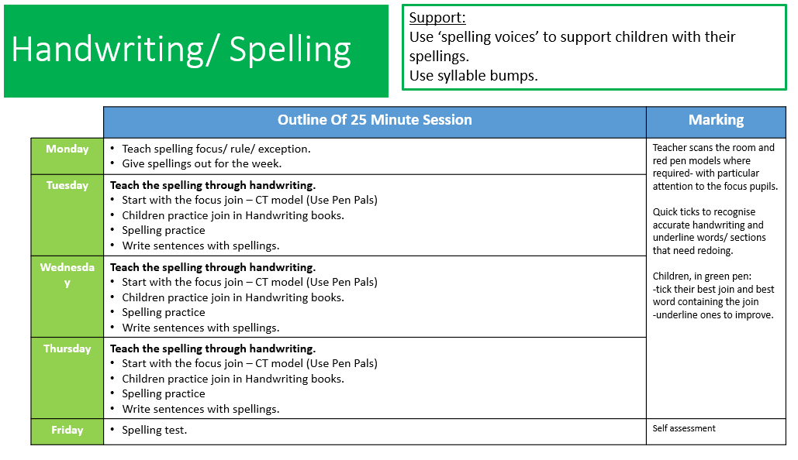
At St. Monica’s Spelling is taught through the handwriting sessions every morning for 25 minutes and in EYFS and KS1 as part of the RWI programme.

As mentioned, Spelling is first taught in EYFS and Year 1 using the RWI programme, where spellings are linked to the sound children are learning. In Years 2- 6 teachers use the appropriate Spelling List for their year group as stipulated in the 2014 National Curriculum, adding topic-based vocabulary as appropriate.

Handwriting affects any written communication. The effective teaching and mastery of handwriting is of importance for fluency and pace. It is a movement skill which helps with processing, recall and fast and automatic spelling of words; providing space for the writer to concentrate on content and composition. Teachers also have access to the ‘PenPals’ script and resources. Staff model and monitor handwriting across the curriculum. Good presentation is always emphasised. At the discretion of the teacher, pen licences for fountain/ballpoint pens can be issued to children in upper KS2 who have mastered fluent handwriting. Pencil grips are available to improve grip and fine motor control. Left-handed writers should sit on the left-hand side of the table.

All children are encouraged and supported to have:
- Correct posture (two hands used and feet firmly on the floor)
- Correct pencil grip
- Correct movement when forming letters
- Fluency
- Legibility

Grammar and Punctuation:
Grammar and punctuation skills are taught in the context of writing for real purposes. Years 2-6 teachers plan for discrete grammar teaching during literacy lessons throughout the week in accordance with the two-week cycle.

Grammar and punctuation in Year 1, is planned through the RWI programme which links to the National Curriculum aims for Year 1.

Assessment:
At St. Monica’s we use the Hackney Learning Trust’s Fundamentals descriptors to assess children’s progress in literacy each half term. Individual targets are set and discussed with children so that they are clear how to make personal progress across the next half term. Both formative and summative assessments are used to inform planning and to target teaching to the needs of the children as well as to track progress. ‘Rising Stars’ assessments are used in Years 2 – 6 and in KS1, RWI assessments are used to complement teacher judgements in literacy, including SPAG. The Literacy Coordinator monitors literacy books, writing opportunities, assessments, and data, to check individual, class and school progress in Literacy. Reception and Year 1 children are assessed by the Literacy coordinator every half term using the RWI assessment and which is the basis for the RWI groups that children are in.

Daily marking of children’s work is planned out in depth in the two-week cycle. Marking is completed by the teacher, support staff and/ or children (self-assessment/peer assessment). Teachers comments should provide a positive comment (specifically linked to the Learning Objective) and/or a target/next step (See Marking Policy). In KS1 & KS2 children’s writing is ultimately assessed using Fundamentals as well as teacher assessment exemplification. This assessment informs teacher’s planning of guided writing groups, and the setting of appropriate targets and learning intentions for children. In Year 2 and Year 6 children take their SATs in May. Year 1 children undergo the Phonics Screening Check in June. (Those children who do not reach the national threshold sit the check again in the summer term of Year 2.)

Special Needs Provision:
The SEN Co-ordinator liaises with the Literacy Coordinator and class teachers to ensure that the individual needs of pupils with special needs are met and that appropriate targets are set and are regularly reviewed. Where resources permit, it will be the school’s policy for Teaching Assistants to provide extra support for the SEN Literacy group.

Any Education, Health and Care Plans (EHCP) will be linked, where appropriate, to the suitable Year and Term objectives from the National Curriculum. Teachers will be mindful of the literacy needs of the children and differentiate questions and activities to allow all children access. Please also refer to the SEN Policy.

Classroom Organisation:
Every class will have a book corner which includes:
- Picture books

Categorised by genre
KS2 organised by level of difficulty

- Range of fiction
- Poems
- Comics/graphic novels
- Variety of non-fiction
- Cushions, rugs
- Home/setting links
- Story visuals

EYFS/Year 1 classrooms will have a writing area which includes:
- Variety of writing tools, e.g. pencils, pens, chalks
- RWI frieze frames
- Writing prompts
- Range of writing templates (invites, lists etc.)

Teaching resources:
- ST. Monica’s Literacy document – includes all planning/two-week cycle/ allocated books/ SPAG/ OLIs
- Wordsmith – reading, writing and grammar
- Bug Club – reading
- Pen Pals – handwriting
- RWI – phonics and spelling progression
- Rising Stars – assessment tasks and tests

The Subject Coordinator:
The role of the subject leader involves: modelling good practice; being responsible for the upgrading and ordering of resources and arranging for their storage; keeping informed about developments and new initiatives to support the teaching of language and literacy and ensure staff are informed; auditing needs and organise staff training; training staff in teaching and learning of literacy; monitoring planning on a termly basis with the head teacher; scrutiny of books and lesson observations with constructive feedback; supporting teachers in planning and using resources; organising an annual school themed week in collaboration with other staff; updating the school policy when necessary.

The Role of Parents and Carers:
- Talk, talk, talk with your child. Children need to develop good oral language skills to put language into writing, to understand concepts and vocabulary and to be able to debate a point of view.
- Read, read, read to and with your children so they hear and enjoy stories and literary language.
- Fred talk to encourage children in EYFS and KS1 learn their phonics sounds. For example, s-i-t, ch-air, j-u-m-p.
- Play games encouraging memory, vocabulary and sequencing, e.g. card games such as ‘snap’ and ‘Happy Families’, ‘I went shopping and I bought’…..(for listening, sequencing, memory and language) , ‘scrabble’ etc.
- Encourage moulding/modelling, colouring, drawing, tracing, writing to help with pencil control and fluency.
- Practise letters and joined up writing as children who write with ease have more time to think about spelling.
- Find real reasons to write and spell correctly, e.g. write thank you letters, cards, shopping lists.
- Help with harder spellings – break words into syllables and find the difficult part.
- Read aloud, join a library, re-tell stories, and listen to stories on the television or radio.
- Learn the alphabet through songs and games. Use a dictionary, play games involving looking up words, make word books at home.

Literacy Events
- Roald Dahl day
- Poetry day
- Book Week
- Whole school Poetry projects
- Shakespeare week
- Book fair

These days are used as an opportunity to organise events to promote reading and writing for pleasure. Children read, read, read, write book reviews, and take part in creative and expressive story and poetry-related activities. A book fair is held which is popular with children, parents, and staff. Book week ends with a character assembly where children and staff dress up as a book character. Special prizes are awarded to recognise those who have made a significant effort for the occasion.

Agreed by the Governing Body on | 5th October 2020
Review Date | Autumn 2023
Person(s) Responsible | Catarina Rodrigues - Literacy Coordinator

