EYFS LONG TERM TOPIC PLAN
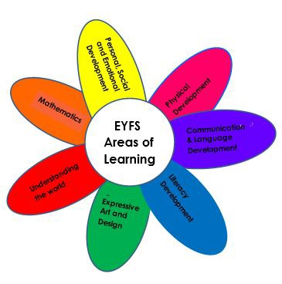

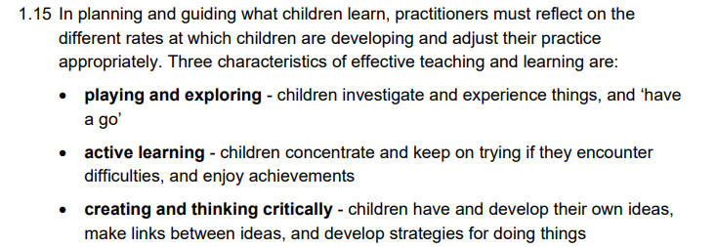

The following has been taken directly from the Statutory framework for early years’ foundation stage (2024). When planning the EYFS provision the following is take into consideration for every element.

There are 12 topic themes that run over a two-year cycle, this ensures that children are exposed to a variety of learning experiences and do not repeat topics.

 | Autumn 1 | Autumn 2 | Spring 1 | Spring 2 | Summer 1 | Summer 2
Nursery | All about me | Journeys | Superheroes | Under the Sea | Animals  On the farm/ ‘mini beasts’ | Space  ‘Out of this World’
Reception | Me & My family | Traditional tales  ‘Once upon a time’ | Kings and Queens | Transport | People who help us  ‘Let’s work’ | The garden

Each topic has several books allocated (1 per week). Use sequence below to support teaching of early Literacy.
Monday | Tuesday | Wednesday | Thursday | Friday
Read the book  - Use puppets  - small people  - props | Retell/ sequence story | Story map | Role play (focus on oracy and vocabulary) | Writing activity

Autumn 1
Nursery
All about me
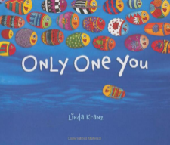  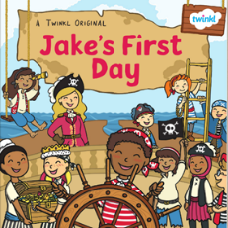  Books  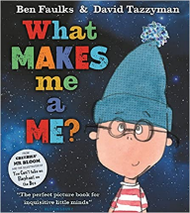  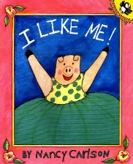  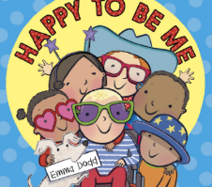  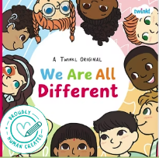  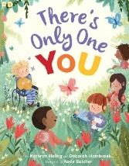 | Home corner  - House home corner  - Kitchen  - Bedroom  - Mirror | Cross curricular links:  Art & Design – Painting; finger painting, brush painting and colour mixing  History – Pictures of babies (Past & Present)  Science- The life cycle of a baby or a frog
Sub topics  Black History week  Changing seasons (UW/ Science) | Celebrations  Harvest festival | Trips

Autumn 1
Reception
Me and My family
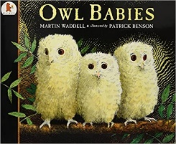  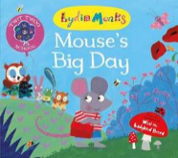  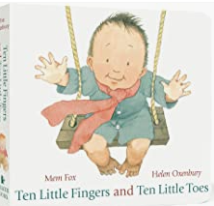  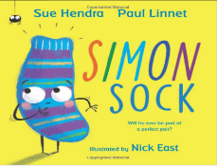  Books  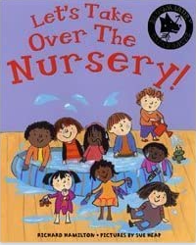  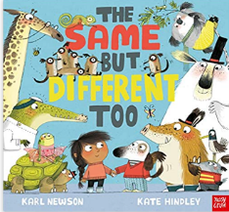  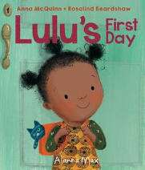 | Home corner  - Home  - School  - Family | Cross curricular links:  Art & Design – Collage; materials to make portrait  History – Pictures of babies (Past & Present)  Science- Life cycle of a frog/ Observing how season change and how we wear different clothing in different seasons.
Sub topics  Black History week  Changing seasons | Celebrations  Harvest festival | Trips

Autumn 2
Nursery
Journeys
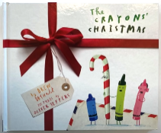  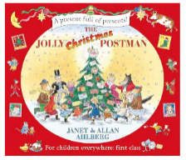    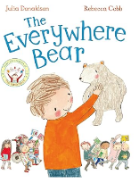  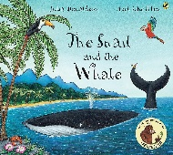  Books  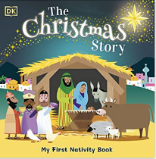 | Home corner  - Different habitats  - Sign post  - Binoculars  - Maps etc.  Christmas:  - Manger  - Animals  - baby | Cross curricular links:  History – Display pictures of old transport methods (Jesus travelled on donkey)  ART – Using vehicles to create pattern and lines.  Science- Observing how seasons change over time and what happens to the trees and plants around us.  Literacy – Mark making – snail trails / role play  Literacy – writing Christmas letters
Sub topics  Art Week  Changing seasons  Anti-bullying week | Celebrations  Advent  Christmas | Trips

Autumn 2
Reception
Traditional tales - ‘Once upon a time’
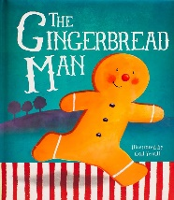  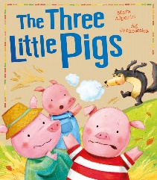  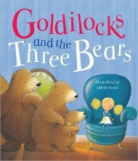  Books | Home corner  - Enchanted forest  - Baking shop  - Houses made of different ‘materials’  Christmas:  - Manger  - Animals  - baby | Cross curricular links:  D&T: Make gingerbread men  Science: Looking at different materials (The Three Little Pigs)  Literacy: Story maps/ Writing letters/ sequencing events.
Sub topics  Art Week  Changing seasons  Anti-bullying week | Celebrations  Advent  Christmas | Trips

Autumn Term - Birth to Three

Communication & Language | Personal, Social and Emotional Development | Physical Development
Children will be learning to:  • Turn towards familiar sounds. They are also startled by loud noises and accurately locate the source of a familiar person’s voice, such as their key person or a parent.  • Gaze at faces, copying facial expressions and movements like sticking out their tongue. Make eye contact for longer periods.  • Watch someone’s face as they talk.  • Make sounds to get attention in different ways (for example, crying when hungry or unhappy, making gurgling sounds, laughing, cooing or babbling).  • Generally focus on an activity of their own choice and find it difficult to be directed by an adult. | Children will be learning to:  • Find ways to calm themselves, through being calmed and comforted by their key person.  • Establish their sense of self.  • Engage with others through gestures, gaze and talk.  • Look back as they crawl away from their key person. | Children will be learning to:  • Lift their head while lying on their front.  • Push their chest up with straight arms.  • Roll over: from front to back, then back to front.  • Enjoy moving when outdoors and inside.

Literacy | Mathematics | Understanding the World | Expressive Arts and Design
Children will be learning to:  • Enjoy songs and rhymes, tuning in and paying attention.  • Copy finger movements and other gestures.  • Enjoy sharing books with an adult. | Children will be learning to:  • Combine objects like stacking blocks and cups. Put objects inside others and take them out again.  • React to changes of amount in a group of up to three items. | Children will be learning to:  • Repeat actions that have an effect.  • Explore materials with different properties. | Children will be learning to:  • Show attention to sounds and music.  • Explore a range of sound-makers and instruments and play them in different ways.  • Explore their voices and enjoy making sounds.  • Notice patterns with strong contrasts and be attracted by patterns resembling the human face.

Autumn Term – Nursery (Three to Four year olds)

Communication & Language | Personal, Social and Emotional Development | Physical Development
Children will be learning to:  • Enjoy listening to longer stories and can remember much of what happens.  • Understand a question or instruction that has two parts, such as: “Get your coat and wait at the door”.  • Sing a large repertoire of songs.  • Know many rhymes, be able to talk about familiar books, and be able to tell a long story.  • Develop their communication, but may continue to have problems with irregular tenses and plurals.  • Use talk to organise themselves and their play: “Let’s go on a bus... you sit there... I’ll be the driver.” | Children will be learning to:  • Select and use activities and resources, with help when needed. This helps them to achieve a goal they have chosen, or one which is suggested to them.  • Become more outgoing with unfamiliar people, in the safe context of their setting.  • Play with one or more other children, extending and elaborating play ideas.  • Increasingly follow rules, understanding why they are important.  • Develop appropriate ways of being assertive.  • Talk about their feelings using words like ‘happy’, ‘sad’, ‘angry’ or ‘worried’. | Children will be learning to:  • Continue to develop their movement, balancing, riding (scooters, trikes and bikes) and ball skills.  • Go up steps and stairs, or climb up apparatus, using alternate feet.  • Start taking part in some group activities which they make up for themselves, or in teams.  • Choose the right resources to carry out their own plan. For example, choosing a spade to enlarge a small hole they dug with a trowel.  • Use one-handed tools and equipment, for example, making snips in paper with scissors

Literacy | Mathematics | Understanding the World | Expressive Arts and Design
Children will be learning to:  • Understand the five key concepts about print: print has meaning; print can have different purposes; we read English text from left to right and from top to bottom; the names of the different parts of a book; page sequencing.  • Develop their phonological awareness, so that they can: spot and suggest rhymes; count or clap syllables in a word; recognise words with the same initial sound, such as money and mother. | Children will be learning to:  • Develop fast recognition of up to 3 objects, without having to count them individually (‘subitising’).  • Recite numbers past 5.  • Say one number for each item in order: 1,2,3,4,5.  • Experiment with their own symbols and marks as well as numerals.  • Talk about and explore 2D and 3D shapes (for example, circles, rectangles, triangles and cuboids) using informal and mathematical language: ‘sides’, ‘corners’; ‘straight’, ‘flat’, ‘round’.  • Understand position through words alone – for example, “The bag is under the table,” – with no pointing.  • Make comparisons between objects relating to size, length, weight and capacity.  • Talk about and identify the patterns around them. For example: stripes on clothes, designs on rugs and wallpaper. Use informal language like ‘pointy’, ‘spotty’, ‘blobs’ etc. | Children will be learning to:  • Use all their senses in hands-on exploration of natural materials.  • Begin to make sense of their own life-story and family’s history.  • Plant seeds and care for growing plants.  • Explore and talk about different forces they can feel.  • Talk about the differences between materials and changes they notice.  • Know that there are different countries in the world and talk about the differences they have experienced or seen in photos.  • Continue developing positive attitudes about the differences between people. | Children will be learning to:  • Take part in simple pretend play, using an object to represent something else even though they are not similar.  • Explore different materials freely, in order to develop their ideas about how to use them and what to make.  • Create closed shapes with continuous lines, and begin to use these shapes to represent objects.  • Explore colour and colour-mixing.  • Listen with increased attention to sounds.  • Remember and sing entire songs.  • Sing the pitch of a tone sung by another person (‘pitch match’).  • Sing the melodic shape (moving melody, such as up and down, down and up) of familiar songs.

Autumn Term - Reception

Communication & Language | Personal, Social and Emotional Development | Physical Development
Children will be learning to:  • Learn new vocabulary.  • Understand how to listen carefully and why listening is important.  • Ask questions to find out more and to check they understand what has been said to them.  • Describe events in some detail.  • Develop social phrases.  • Engage in story times.  • Listen carefully to rhymes and songs, paying attention to how they sound.  • Engage in non-fiction books. | Children will be learning to:  • See themselves as a valuable individual.  • Build constructive and respectful relationships.  • Express their feelings and consider the feelings of others.  • Show resilience and perseverance in the face of challenge.  • Identify and moderate their own feelings socially and emotionally.  • Think about the perspectives of others.  • Manage their own needs. | Children will be learning to:  • Revise and refine the fundamental movement skills they have already acquired: rolling, crawling, walking, jumping, running, hopping, skipping, climbing.  • Develop their small motor skills so that they can use a range of tools competently, safely and confidently. Suggested tools: pencils for drawing and writing, paintbrushes, scissors, knives, forks and spoons.  • Confidently and safely use a range of large and small apparatus indoors and outside, alone and in a group.  • Develop overall body-strength, balance, co-ordination and agility.  • Further develop the skills they need to manage the school day successfully: lining up and queuing, mealtimes and personal hygiene.

Literacy | Mathematics | Understanding the World | Expressive Arts and Design
Children will be learning to:  • Read individual letters by saying the sounds for them.  • Blend sounds into words, so that they can read short words made up of known letter–sound correspondences.  • Read some letter groups that each represent one sound and say sounds for them.  • Read a few common exception words matched to the school’s phonic programme.  • Form lower-case and capital letters correctly.. | Children will be learning to:  • Count objects, actions and sounds.  • Subitise - look at a group of objects and realise how many there are without counting.  • Link the number symbol (numeral) with its cardinal number value.  • Select, rotate and manipulate shapes in order to develop spatial reasoning skills.  • Continue, copy and create rep[eating patterns. | Children will be learning to:  • Talk about members of their immediate family and community.  • Compare and contrast characters from stories, including figures from the past.  • Understand that some places are special to members of their community. • Explore the natural world around them.  • Describe what they see, hear and feel whilst outside.  • Understand the effect of changing seasons on the natural world around them. | Children will be learning to:  • Explore, use and refine a variety of artistic effects to express their ideas and feelings.  • Listen attentively, move to and talk about music, expressing their feelings and responses.  • Develop storylines in their pretend play.  • Create their own songs, or improvise a song around one they know.

Spring 1
Nursery
Superheroes
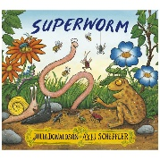  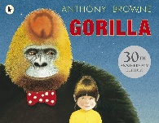  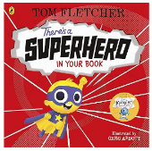  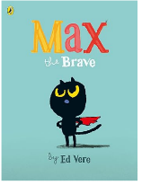  Books  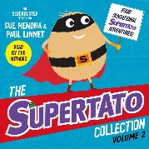 | Home corner  - Mini city  - Superhero hideout  - Eye masks  - Walkie talkies  - Superhero HQ  - Telephones | Suggested activities  - Art & Design – Making prints on fabric for superhero cape  - History – Significant people
Sub topics  Changing seasons  Growth mindset week | Celebrations | Trips

Spring 1
Reception
Kings & Queens
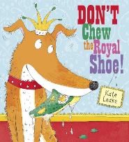  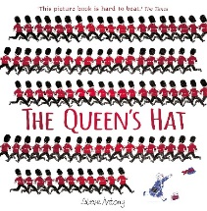  Books  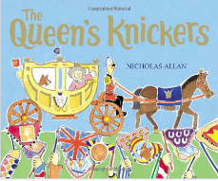  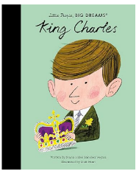  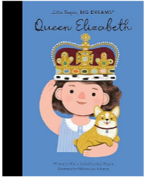 | Home corner  - Castle  - Crowns  - Tiaras  - Throne | Cross curricular links:  Art & Design – Painting; textures on a crown  History – Present King & Past kings and queens on a string displayed
Sub topics  Changing seasons  Growth mindset week | Celebrations | Trips

Spring 2
Nursery
Under the sea
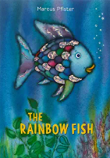  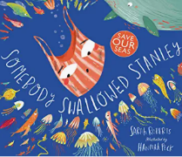  Books  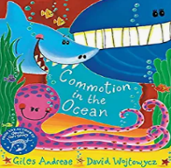  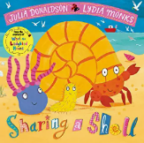  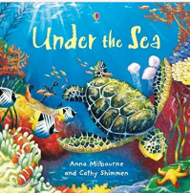  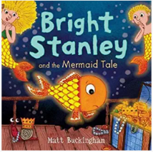 | Home corner  - Create an under the sea environment  - Goggles  - Flippers  - Fish | Cross curricular links:  Art & Design – Make a fish using colour collage.  Geography – Maps where are the seas? Globe for children to explore  Maths – counting scales/ Matching fish  Literacy – description of fish (oracy)
Sub topics  Changing seasons  Shakespeare week | Celebrations  Lent  World Book Day | Trips

Spring 2
Reception
Transport
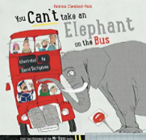  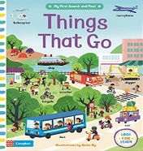  Books  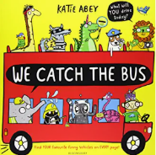  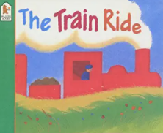  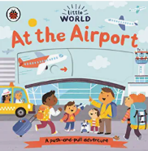  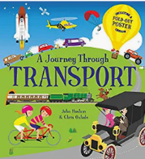 | Home corner  - Travel agency  - Phone  - Mark making tickets  - Maps  - Travel brochures | Suggested activities  - History – Past & Present  - Art & Design – Pattern making  - Maths – counting wheels. Which has more? How many people can fit?  - Literacy – recount of bus journey/ bus schedules
Sub topics  Changing seasons  Shakespeare week | Celebrations  Lent  World Book Day | Trips  - Go on a bus  - Go to the local library find books on transport

Spring Term - Birth to Three

Communication & Language | Personal, Social and Emotional Development | Physical Development
Children will be learning to:  • Copy what adults do, taking ‘turns’ in conversations (through babbling) and activities. Try to copy adult speech and lip movements.  • Enjoy singing, music and toys that make sounds.  • Babble, using sounds like ‘baba’, ‘mamama’.  • Reach or point to something they want while making sounds. • Copy your gestures and words.  • Constantly babble and use single words during play.  • Understand single words in context – ‘cup’, ‘milk’, ‘daddy’.  • Understand frequently used words such as ‘all gone’, ‘no’ and ‘bye-bye’.  • Listen to other people’s talk with interest, but can easily be distracted by other things.  • Make themselves understood, and can become frustrated when they cannot.  • Start to develop conversation, often jumping from topic to topic.  • Develop pretend play: ‘putting the baby to sleep’ or ‘driving the car to the shops’.  • Listen to simple stories and understand what is happening, with the help of the pictures | Children will be learning to:  • Express preferences and decisions. They also try new things and start establishing their autonomy.  • Use that engagement to achieve a goal. For example, gesture towards their cup to say they want a drink.  • Find ways of managing transitions, for example from their parent to their key person.  • Look back as they crawl or walk away from their key person. Look for clues about how to respond to something interesting.  • Play with increasing confidence on their own and with other children, because they know their key person is nearby and available.  • Feel strong enough to express a range of emotions.  • Grow in independence, rejecting help (“me do it”). Sometimes this leads to feelings of frustration and tantrums.  • Begin to show ‘effortful control’. For example, waiting for a turn and resisting the strong impulse to grab what they want or push their way to the front.  • Develop friendships with other children. | Children will be learning to:  • Sit without support.  • Begin to crawl in different ways and directions.  • Pull themselves upright and bouncing in preparation for walking.  • Reach out for objects as co-ordination develops.  • Pass things from one hand to the other. Let go of things and hand them to another person, or drop them.  • Gradually gain control of their whole body through continual practice of large movements, such as waving, kicking, rolling, crawling and walking.  • Clap and stamp to music.  • Fit themselves into spaces, like tunnels, dens and large boxes, and move around in them.  • Begin to walk independently – choosing appropriate props to support at first.  • Sit on a push-along wheeled toy.  • Show an increasing desire to be independent, such as wanting to feed themselves and dress or undress.

Literacy | Mathematics | Understanding the World | Expressive Arts and Design
Children will be learning to:  • Join in with songs and rhymes, copying sounds, rhythms, tunes and tempo.  • Say some of the words in songs and rhymes. • Pay attention and respond to the pictures or the words.  • Have favourite books and seek them out, to share with an adult, with another child, or to look at alone.  • Repeat words and phrases from familiar stories.  • Enjoy drawing freely. | Children will be learning to:  • Take part in finger rhymes with numbers.  • Compare amounts, saying ‘lots’, ‘more’ or ‘same’.  • Develop counting-like behaviour, such as making sounds, pointing or saying some numbers in sequence.  • Climb and squeeze themselves into different types of spaces.  • Build with a range of resources. | Children will be learning to:  • Explore natural materials, indoors and outside.  • Explore and respond to different natural phenomena in their setting and on trips. | Children will be learning to:  • Respond emotionally and physically to music when it changes.  • Anticipate phrases and actions in rhymes and songs, like ‘Peepo’.  • Join in with songs and rhymes, making some sounds.  • Start to make marks intentionally.  • Explore paint, using fingers and other parts of their bodies as well as brushes and other tools.  • Manipulate and play with different materials. • Enjoy and take part in action songs, such as ‘Twinkle, Twinkle Little Star’.  • Start to develop pretend play, pretending that one object represents another. For example, a child holds a wooden block to her ear and pretends it’s a phone.

Spring Term – Three to Four

Communication & Language | Personal, Social and Emotional Development | Physical Development
Children will be learning to:  • Pay attention to more than one thing at a time, which can be difficult.  • Understand ‘why’ questions, like: “Why do you think the caterpillar got so fat?”  • Sing a large repertoire of songs.  • Know many rhymes, be able to talk about familiar books, and be able to tell a long story.  • Develop their pronunciation.  • Start a conversation with an adult or a friend and continue it for many turns. | Children will be learning to:  • Develop their sense of responsibility and membership of a community.  • Become more outgoing with unfamiliar people, in the safe context of their setting.  • Play with one or more other children, extending and elaborating play ideas.  • Increasingly follow rules, understanding why they are important  • Talk with others to solve conflicts.  • Talk about their feelings using words like ‘happy’, ‘sad’, ‘angry’ or ‘worried’. | Children will be learning to:  • Continue to develop their movement, balancing, riding (scooters, trikes and bikes) and ball skills.  • Use large-muscle movements to wave flags and streamers, paint and make marks.  • Skip, hop, stand on one leg and hold a pose for a game like musical statues.  • Start taking part in some group activities which they make up for themselves, or in teams.  • Match their developing physical skills to tasks and activities in the setting. For example, they decide whether to crawl, walk or run across a plank, depending on its length and width.  • Collaborate with others to manage large items, such as moving a long plank safely, carrying large hollow blocks.  • Use a comfortable grip with good control when holding pens and pencils.  • Start eating independently and learning how to use a knife and fork.  • Be increasingly independent in meeting their own care needs, e.g. brushing teeth, using the toilet, washing and drying their hands thoroughly

Literacy | Mathematics | Understanding the World | Expressive Arts and Design
Children will be learning to:  • Engage in extended conversations about stories, learning new vocabulary.  • Use some of their print and letter knowledge in their early writing. For example: writing a pretend shopping list that starts at the top of the page; writing ‘m’ for mummy.  • Write some or all of their name.  • Write some letters accurately  • Repeat words and phrases from familiar stories.  • Enjoy drawing freely. | Children will be learning to:  • Know that the last number reached when counting a small set of objects tells you how many there are in total (‘cardinal principle’).  • Show ‘finger numbers’ up to 5.  • Link numerals and amounts: for example, showing the right number of objects to match the numeral, up to 5.  • Experiment with their own symbols and marks as well as numerals.  • Talk about and explore 2D and 3D shapes (for example, circles, rectangles, triangles and cuboids) using informal and mathematical language: ‘sides’, ‘corners’; ‘straight’, ‘flat’, ‘round’.  • Describe a familiar route.  • Make comparisons between objects relating to size, length, weight and capacity.  • Talk about and identify the patterns around them. For example: stripes on clothes, designs on rugs and wallpaper. Use informal language like ‘pointy’, ‘spotty’, ‘blobs’ etc. | Children will be learning to:  • Explore collections of materials with similar and/or different properties.  • Show interest in different occupations.  • Plant seeds and care for growing plants.  • Understand the key features of the life cycle of a plant and an animal.  • Explore and talk about different forces they can feel.  • Talk about the differences between materials and changes they notice.  • Know that there are different countries in the world and talk about the differences they have experienced or seen in photos.  • Continue developing positive attitudes about the differences between people. | Children will be learning to:  • Begin to develop complex stories using small world equipment like animal sets, dolls and dolls houses etc.  • Develop their own ideas and then decide which materials to use to express them.  • Draw with increasing complexity and detail, such as representing a face with a circle and including details.  • Use drawing to represent ideas like movement or loud noises.  • Listen with increased attention to sounds.  • Remember and sing entire songs.  • Create their own songs, or improvise a song around one they know.

Springs Term – Reception

Communication & Language | Personal, Social and Emotional Development | Physical Development
Children will be learning to:  • Use new vocabulary through the day.  • Understand how to listen carefully and why listening is important.  • Articulate their ideas and thoughts in well-formed sentences. • Use talk to help work out problems and organise thinking and activities, and to explain how things work and why they might happen.  • Listen to and talk about stories to build familiarity and understanding.  • Use new vocabulary in different contexts.  • Learn rhymes, poems and songs.  • Listen to and talk about selected non-fiction to develop a deep familiarity with new knowledge and vocabulary | Children will be learning to:  • See themselves as a valuable individual.  • Build constructive and respectful relationships.  • Express their feelings and consider the feelings of others.  • Show resilience and perseverance in the face of challenge.  • Identify and moderate their own feelings socially and emotionally.  • Think about the perspectives of others.  • Manage their own needs. | Children will be learning to:  • Progress towards a more fluent style of moving, with developing control and grace.  • Develop their small motor skills so that they can use a range of tools competently, safely and confidently. Suggested tools: pencils for drawing and writing, paintbrushes, scissors, knives, forks and spoons.  • Use their core muscle strength to achieve a good posture when sitting at a table or sitting on the floor.  • Confidently and safely use a range of large and small apparatus indoors and outside, alone and in a group.  • Develop overall body-strength, balance, co-ordination and agility.  • Combine different movements with ease and fluency.  • Further develop the skills they need to manage the school day successfully: lining up and queuing, mealtimes and personal hygiene.

Literacy | Mathematics | Understanding the World | Expressive Arts and Design
Children will be learning to:  • Read simple phrases and sentences made up of words with known letter– sound correspondences and, where necessary, a few exception words.  • Read books to build up their confidence in word reading, their fluency and their understanding and enjoyment.  • Spell words by identifying the sounds and then writing the sound with letter/s.  • Form lower-case and capital letters correctly. • Repeat words and phrases from familiar stories. . | Children will be learning to:  • Count objects, actions and sounds.  • Subitise - look at a group of objects and realise how many there are without counting. • Count objects, actions and sounds.  • Link the number symbol (numeral) with its cardinal number value.  • Count beyond ten.  • Compare numbers.  • Understand the ‘one more than/one less than’ relationship between consecutive numbers.  • Explore the composition of numbers to 10.  • Compose and decompose shapes so that children recognise a shape can have other shapes within it, just as numbers can.  • Continue, copy and create repeating patterns.  • Compare length, weight and capacity | Children will be learning to:  • Name and describe people who are familiar to them.  • Comment on images of familiar situations in the past.  • Recognise that people have different beliefs and celebrate special times in different ways.  • Explore the natural world around them.  • Describe what they see, hear and feel whilst outside.  • Understand the effect of changing seasons on the natural world around them. | Children will be learning to:  • Explore, use and refine a variety of artistic effects to express their ideas and feelings.  • Return to and build on their previous learning, refining ideas and developing their ability to represent them.  • Develop storylines in their pretend play.  • Listen attentively, move to and talk about music, expressing their feelings and responses. • Watch and talk about dance and performance art, expressing their feelings and responses.  • Sing in a group or on their own, increasingly matching the pitch and following the melody

Summer 1
Nursery
One the farm/ mini beasts
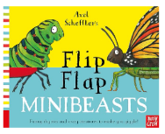  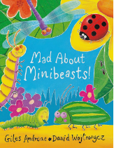  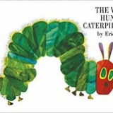  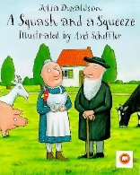  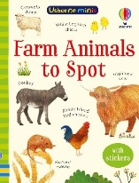  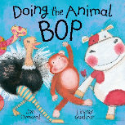  Books | Home corner  - Farm barn  - Farm equipment  - Chickens & eggs  - Mini beast hotel  - Mini beasts dress up costume | Suggested activities  - R.E: Link to new life (Jesus’ resurrection) – chicks being born  - Understanding the world – Where is our local farm?  - Sequencing food/ days from ‘The hungry caterpillar’  - Science- Caterpillar – butterfly  - Maths – Counting – fewer/ more
Sub topics  Changing seasons | Celebrations | Trips  Local farm – hackney farm  Eco Garden

Summer 1
Reception
People who help us ‘Let’s work’
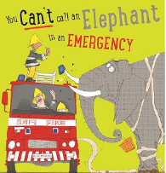  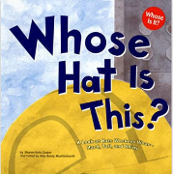  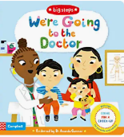  Books  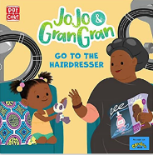  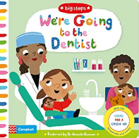  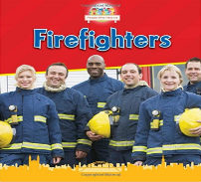 | Home corner  - Fire station  - Dress up  - Police station  - Doctors  - Clipboards  - Pencils | Suggested activities  - Understanding the world – people’s jobs  - Science – materials – What do fire men wear?  - Parents to come in and talk about their jobs  - Literacy – Job application
Sub topics  Changing seasons | Celebrations | Trips  Local fire station  Police visit school

Summer 2
Nursery
Space ‘Out of this World’
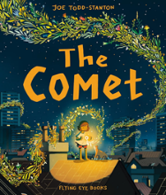    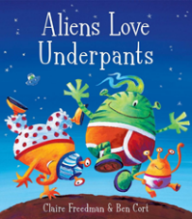  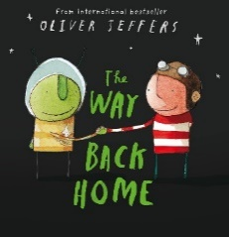  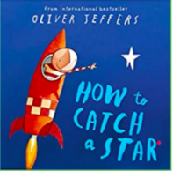  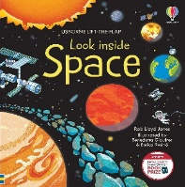  Books  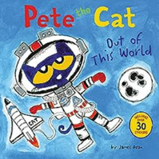 | Home corner  - Space station  - Magnifying glass  - Moon rocks  - Aliens  - Face masks  - Space helmets  - Observation station – mark making | Cross curricular links:  Art & Design – Drawing; using a pencil to make different lines on planets  Art & Design (motor skills) – using scissors to cut out aliens  Maths – comparing aliens size. How big? How small?  Literacy – Mark making – naming aliens ‘maisey mountain – m’
Sub topics  Changing seasons  Art week | Celebrations  Summer Fayre | Trips

Summer 2
Reception
The Garden
Books  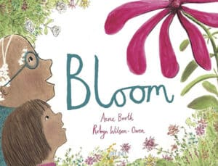  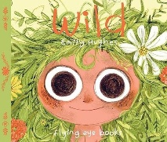  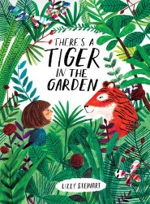  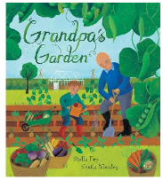  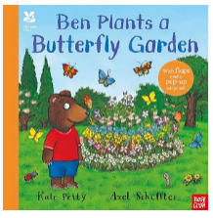  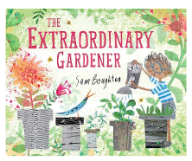 | Home corner  - Garden centre  - Planting  - Plants  - Till and cash | Cross Curricular Links:  Art & Design: My New Year; drawing of them in their new class and sharing with others  Science – Planting  Literacy – Instructions – plant a flower  Understanding the world – bees. Why are bees important?  Maths – Counting petals (beyond 10)
Sub topics  Changing seasons  Art week  Phonics screening | Celebrations  Summer Fayre | Trips  Garden

Summer Term – Birth to Three

Communication & Language | Personal, Social and Emotional Development | Physical Development
Children will be learning to:  • Recognise and are calmed by a familiar and friendly voice.  • Listen and respond to a simple instruction.  • Use gestures like waving and pointing to communicate.  • Use intonation, pitch and changing volume when ‘talking’.  • Understand simple instructions like “give to nanny” or “stop”.  • Recognise and point to objects if asked about them.  • Start to say how they are feeling, using words as well as actions.  • Use the speech sounds p, b, m, w.  • Pronounce: - l/r/w/y - s/sh/ch/dz/j - f/th - multi-syllabic words such as ‘banana’ and ‘computer’  • Identify familiar objects and properties for practitioners when they are described. For example: ‘Katie’s coat’, ‘blue car’, ‘shiny apple’.  • Understand and act on longer sentences like ‘make teddy jump’ or ‘find your coat’.  • Understand simple questions about ‘who’, ‘what’ and ‘where’ (but generally not ‘why’). | Children will be learning to:  • Thrive as they develop self-assurance.  • Feel confident when taken out around the local neighbourhood, and enjoy exploring new places with their key person.  • Be increasingly able to talk about and manage their emotions. • Notice and ask questions about differences, such as skin colour, types of hair, gender, special needs and disabilities, and so on.  • Safely explore emotions beyond their normal range through play and stories.  • Talk about their feelings in more elaborated ways: “I’m sad because...” or “I love it when ...”.  • Learn to use the toilet with help, and then independently | Children will be learning to:  • Enjoy starting to kick, throw and catch balls.  • Build independently with a range of appropriate resources.  • Walk, run, jump and climb – and start to use the stairs independently.  • Spin, roll and independently use ropes and swings (for example, tyre swings).  • Use a scooter or ride a tricycle.  • Use large and small motor skills to do things independently, for example manage buttons and zips, and pour drinks.  • Start eating independently and learning how to use a knife and fork.  • Develop manipulation and control.  • Explore different materials and tools.

Literacy | Mathematics | Understanding the World | Expressive Arts and Design
Children will be learning to:  • Sing songs and say rhymes independently, for example, singing whilst playing.  • Ask questions about the book. Makes comments and shares their own ideas.  • Develop play around favourite stories using props.  • Notice some print, such as the first letter of their name, a bus or door number, or a familiar logo.  • Add some marks to their drawings, which they give meaning to. For example: “That says mummy.”  • Make marks on their picture to stand for their name. | Children will be learning to:  • Count in everyday contexts, sometimes skipping numbers - ‘1-2-3-5.’  • Complete inset puzzles.  • Compare sizes, weights etc. using gesture and language - ‘bigger/little/smaller’, ‘high/low’, ‘tall’, ‘heavy’.  • Notice patterns and arrange things in patterns. | Children will be learning to:  • Make connections between the features of their family and other families.  • Notice differences between people. | Children will be learning to:  • Move and dance to music.  • Make rhythmical and repetitive sounds.  • Express ideas and feelings through making marks, and sometimes give a meaning to the marks they make.  • Explore different materials, using all their senses to investigate them.  • Use their imagination as they consider what they can do with different materials.  • Make simple models which express their ideas.

Summer Term – Three to Four Year Olds
Communication & Language | Personal, Social and Emotional Development | Physical Development
Children will be learning to:  • Pay attention to more than one thing at a time, which can be difficult.  • Use a wider range of vocabulary.  • Sing a large repertoire of songs.  • Know many rhymes, be able to talk about familiar books, and be able to tell a long story.  • Develop their pronunciation.  • Use longer sentences of four to six words.  • Be able to express a point of view and to debate when they disagree with an adult or a friend, using words as well as actions. | Children will be learning to:  • Develop their sense of responsibility and membership of a community.  • Show more confidence in new social situations. • Find solutions to conflicts and rivalries. For example, accepting that not everyone can be Spider-Man in the game, and suggesting other ideas.  • Remember rules without needing an adult to remind them.  • Talk with others to solve conflicts.  • Understand gradually how others might be feeling. | Children will be learning to:  • Continue to develop their movement, balancing, riding (scooters, trikes and bikes) and ball skills.  • Use large-muscle movements to wave flags and streamers, paint and make marks.  • Skip, hop, stand on one leg and hold a pose for a game like musical statues.  • Increasingly be able to use and remember sequences and patterns of movements which are related to music and rhythm. • Match their developing physical skills to tasks and activities in the setting. For example, they decide whether to crawl, walk or run across a plank, depending on its length and width.  • Collaborate with others to manage large items, such as moving a long plank safely, carrying large hollow blocks.  • Show a preference for a dominant hand.  • Be increasingly independent as they get dressed and undressed, for example, putting coats on and doing up zips.  • Make healthy choices about food, drink, activity and tooth brushing.

Literacy | Mathematics | Understanding the World | Expressive Arts and Design
Children will be learning to:  • Engage in extended conversations about stories, learning new vocabulary.  • Use some of their print and letter knowledge in their early writing. For example: writing a pretend shopping list that starts at the top of the page; writing ‘m’ for mummy.  • Write some or all of their name.  • Write some letters accurately.  • Make marks on their picture to stand for their name. | Children will be learning to:  • Solve real world mathematical problems with numbers up to 5.  • Compare quantities using language: ‘more than’, ‘fewer than’.  • Discuss routes and locations, using words like ‘in front of’ and ‘behind’.  • Select shapes appropriately: flat surfaces for building, a triangular prism for a roof etc.  • Combine shapes to make new ones - an arch, a bigger triangle etc.  • Extend and create ABAB patterns – stick, leaf, stick, leaf.  • Notice and correct an error in a repeating pattern.  • Begin to describe a sequence of events, real or fictional, using words such as ‘first’, ‘then...’ | Children will be learning to:  • Talk about what they see, using a wide vocabulary.  • Explore how things work.  • Understand the key features of the life cycle of a plant and an animal.  • Begin to understand the need to respect and care for the natural environment and all living things.  • Explore and talk about different forces they can feel.  • Talk about the differences between materials and changes they notice.  • Know that there are different countries in the world and talk about the differences they have experienced or seen in photos.  • Continue developing positive attitudes about the differences between people. | Children will be learning to:  • Make imaginative and complex ‘small worlds’ with blocks and construction kits, such as a city with different buildings and a park.  • Join different materials and explore different textures.  • Show different emotions in their drawings and paintings, like happiness, sadness, fear etc. • Show different emotions in their drawings – happiness, sadness, fear etc.  • Respond to what they have heard, expressing their thoughts and feelings.

Summer Term – Reception
Communication & Language | Personal, Social and Emotional Development | Physical Development
Children will be learning to:  • Use new vocabulary through the day.  • Understand how to listen carefully and why listening is important.  • Articulate their ideas and thoughts in well-formed sentences. • Connect one idea or action to another using a range of connectives.  • Use talk to help work out problems and organise thinking and activities, and to explain how things work and why they might happen.  • Retell the story, once they have developed a deep familiarity with the text; some as exact repetition and some in their own words.  • Learn rhymes, poems and songs.  • Listen to and talk about selected non-fiction to develop a deep familiarity with new knowledge and vocabulary. | Children will be learning to:  • See themselves as a valuable individual.  • Build constructive and respectful relationships.  • Express their feelings and consider the feelings of others.  • Show resilience and perseverance in the face of challenge.  • Identify and moderate their own feelings socially and emotionally.  • Think about the perspectives of others.  • Manage their own needs | Children will be learning to:  • Develop the overall body strength, co-ordination, balance and agility needed to engage successfully with future physical education sessions and other physical disciplines including dance, gymnastics, sport and swimming.  • Use their core muscle strength to achieve a good posture when sitting at a table or sitting on the floor.  • Further develop and refine a range of ball skills including: throwing, catching, kicking, passing, batting, and aiming.  • Develop confidence, competence, precision and accuracy when engaging in activities that involve a ball.  • Combine different movements with ease and fluency.  • Develop the foundations of a handwriting style which is fast, accurate and efficient.  • Know and talk about the different factors that support their overall health and wellbeing: regular physical activity, healthy eating, tooth brushing, sensible amounts of ‘screen time’, having a good sleep routine, being a safe pedestrian.

Literacy | Mathematics | Understanding the World | Expressive Arts and Design
Children will be learning to:  • Re-read books to build up their confidence in word reading, their fluency and their understanding and enjoyment.  • Spell words by identifying the sounds and then writing the sound with letter/s.  • Form lower-case and capital letters correctly. • Write short sentences with words with known sound-letter correspondences using a capital letter and full stop.  • Re-read what they have written to check that it makes sense. | Children will be learning to:  • Link the number symbol (numeral) with its cardinal number value.  • Count beyond ten.  • Compare numbers.  • Understand the ‘one more than/one less than’ relationship between consecutive numbers.  • Explore the composition of numbers to 10.  • Automatically recall number bonds for numbers 0–10.  • Compose and decompose shapes so that children recognise a shape can have other shapes within it, just as numbers can.  • Continue, copy and create repeating patterns.  • Compare length, weight and capacity. | Children will be learning to:  • Name and describe people who are familiar to them.  • Comment on images of familiar situations in the past.  • Draw information from a simple map.  • Recognise some similarities and differences between life in this country and life in other countries.  • Explore the natural world around them.  • Describe what they see, hear and feel whilst outside.  • Understand the effect of changing seasons on the natural world around them.  • Explore the natural world around them.  • Recognise some environments that are different to the one in which they live. | Children will be learning to:  • Return to and build on their previous learning, refining ideas and developing their ability to represent them.  • Create collaboratively, sharing ideas, resources and skills.  • Develop storylines in their pretend play.  • Watch and talk about dance and performance art, expressing their feelings and responses.  • Sing in a group or on their own, increasingly matching the pitch and following the melody.  • Explore and engage in music making and dance, performing solo or in groups.

